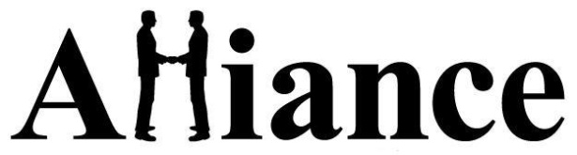

Pneumonia Prevention Tips
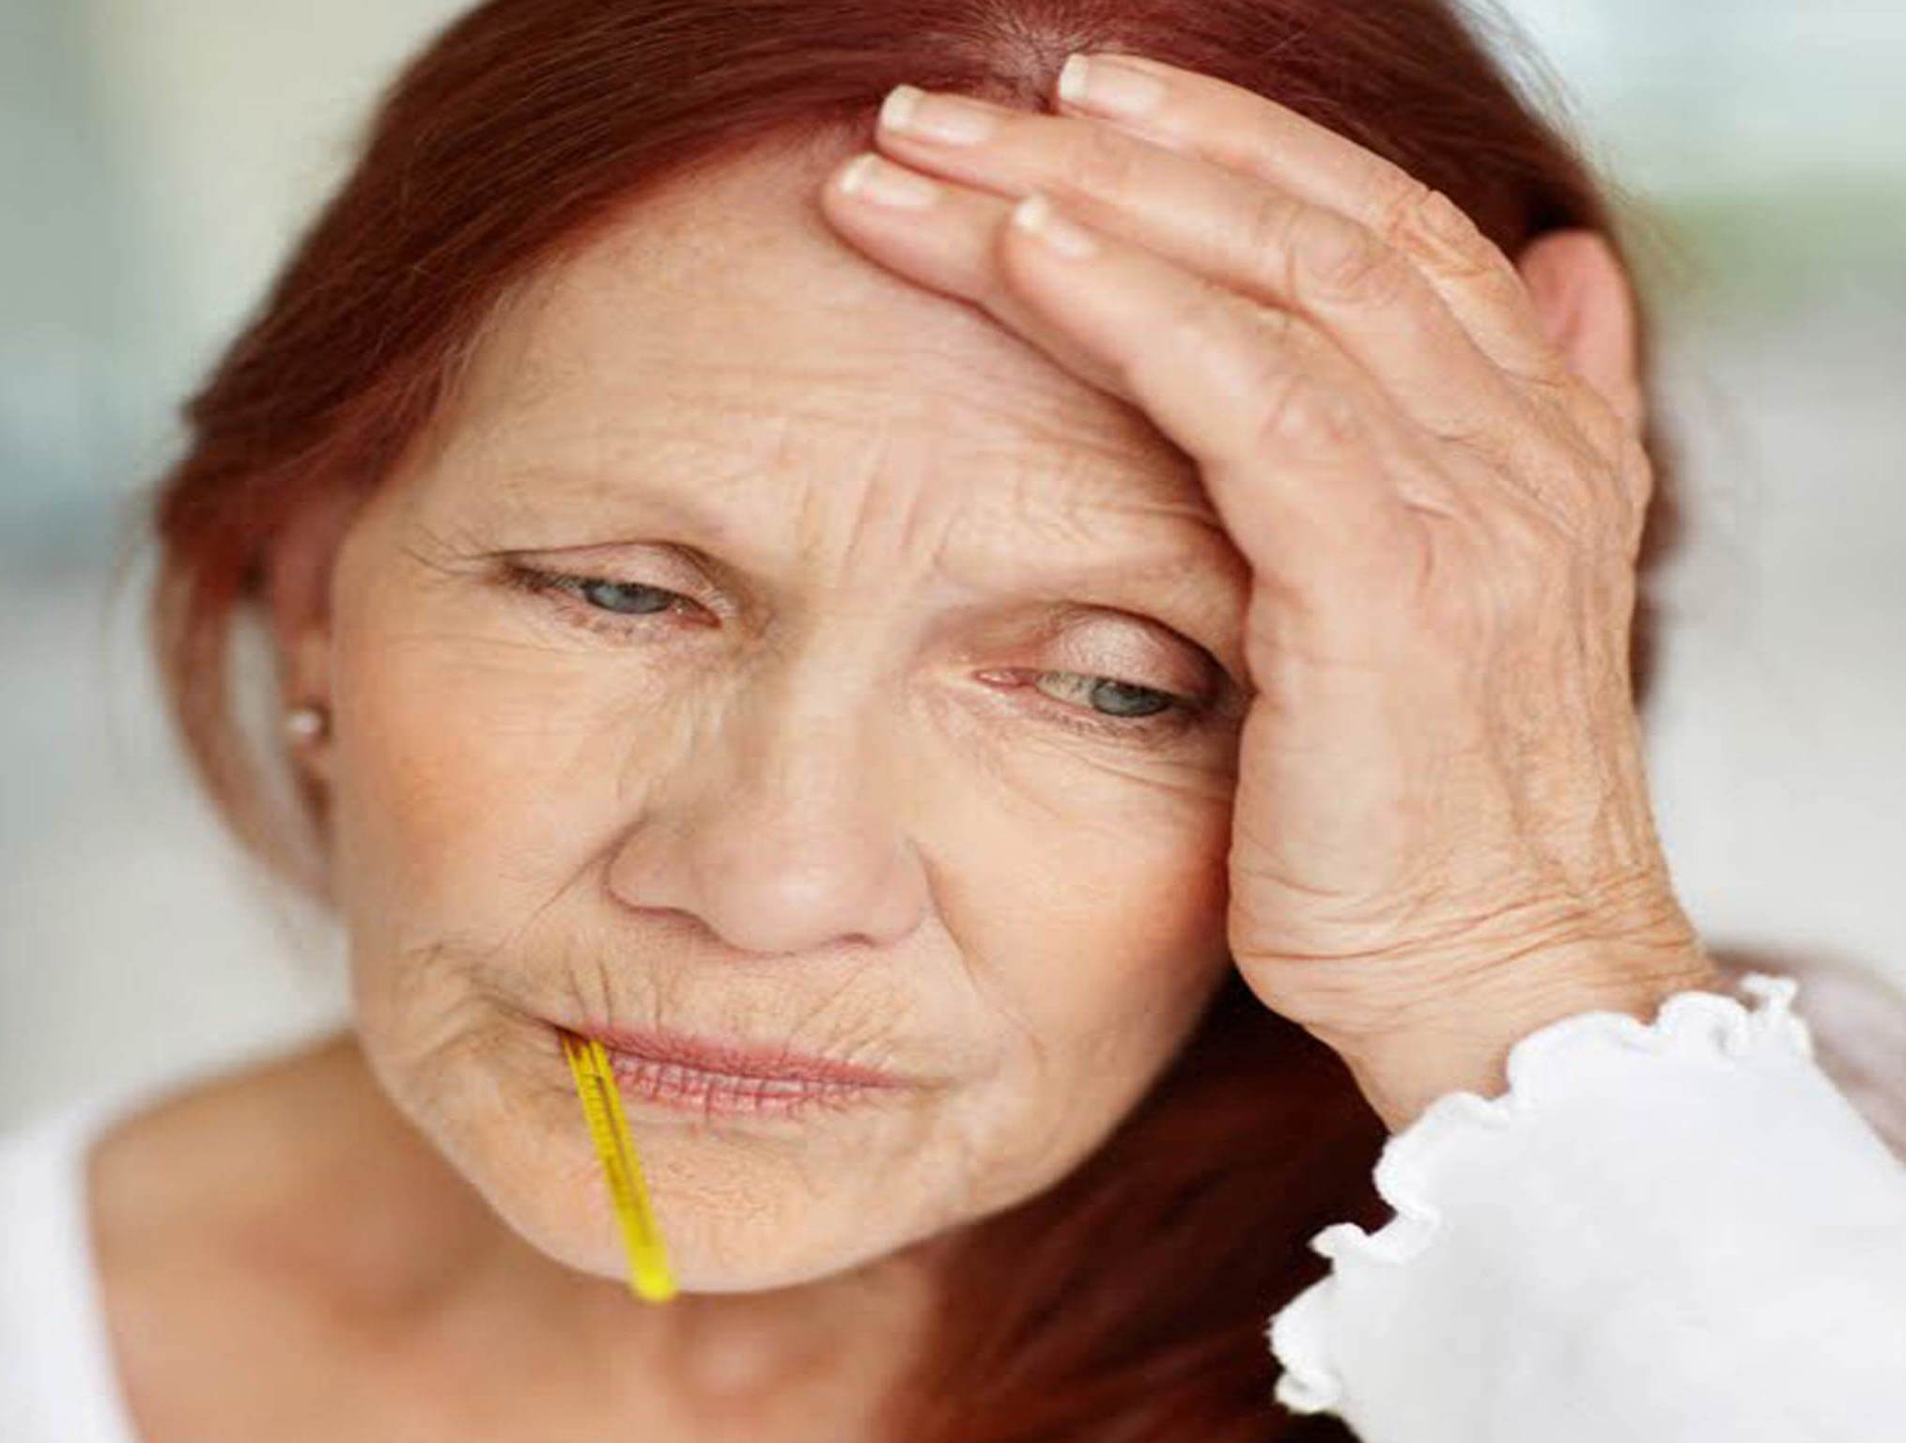
Pneumonia is a common but serious ailment. Our knowledgeable caregivers can help reduce seniors’ chances of coming down with it by encouraging prevention techniques. These include:
- Avoiding smoking
- Asking their doctor about getting the flu shot every fall
- Asking their doctor about the pneumonia vaccine
- Eating a proper diet
- Getting enough exercise and sleep

What Is Pneumonia?

Pneumonia is a general term that refers to an infection of the lungs. It can be caused by a variety of microorganisms, including bacteria, viruses and parasites. Like the flu, pneumonia can cause serious problems for elderly people.
The possible consequences of pneumonia include:
- Fluid around the lungs
- Pus in the pleural cavity (an area between the lungs and chest)
- Low blood sodium
- Abscess in the lungs
- Death

What Are the Risk Factors?

The following things can put you at an increased risk for developing pneumonia:
- Being male
- Being older
- Smoking and breathing secondhand smoke
- Having certain medical conditions, such as heart or lung problems, diabetes, or dementia
- Taking prednisone (a medication)
- Abusing alcohol or drugs
- Being around certain environmental factors

What Are the Symptoms?

The symptoms of pneumonia include:
- Fever
- Chills
- Cough
- Rapid or labored breathing
- Vomiting
- Chest pain
- Sore throat

What’s the Treatment?

If you get pneumonia, your doctor may advise:
- Antibiotics
- Bed rest
- Plenty of fluids
- Therapeutic coughing
- Breathing exercises
- Medication to reduce pain and fever

To learn more about our knowledgeable, reliable, compassionate in-home caregivers and how we can help seniors reduce their risk of getting pneumonia, please contact us today.

